Criterion C: Development
Initializing the product:
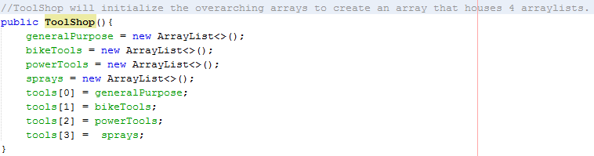

Printing Inventory:
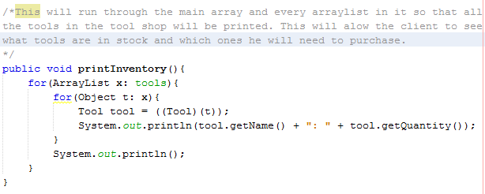
This code was hard to create because it would need to loop through the main array, then through every arraylist calling each name and the quantity of each tool in the inventory.

Interface Class:
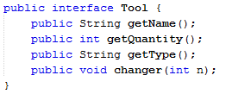
This interface class was used to link all the tools together so that it would be easier to access the different type of tools. This prevents repetive code in the program by making it refer to a certain class based on the object type rather than trying to run it on every project.

Remover:
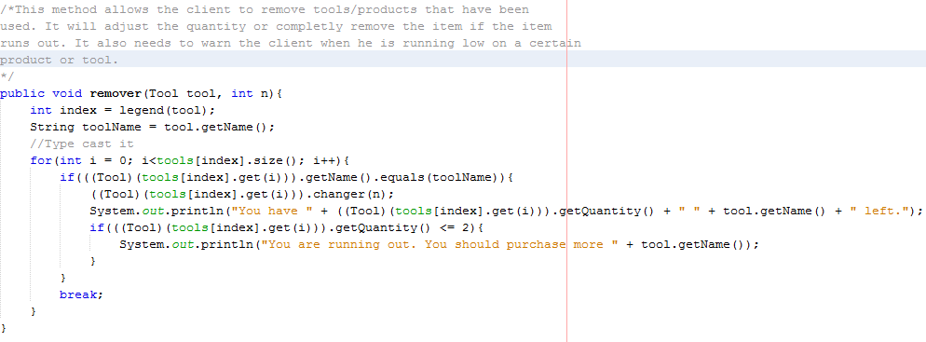
This was the hardest code to write since it needs to identify what tool is imputed, then go to the right section, and finally find the tool. Once it found the tool, the program would then take off n, the quantity that the client wants to remove. After remvoing the quantity, it would need to check to see how much of the item is left and will need to notify the client if the item is running low.

What array slot?
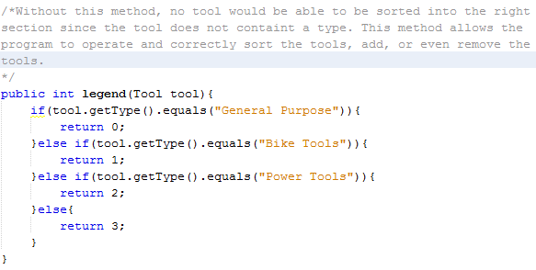

Adder:
